Task Productivity: Verify Tasks — Duration Distribution (with Auto Dispensed)
task_mode: Auto Dispensed (fill_id in 08 Dispensing - Automated) overrides Automated/Manual. Cuts: task, wh_name, task_mode (Auto Dispensed, Automated, Manual), task_mode × task, task_mode × wh_name.

Topline Volume and % of Total
Volume = row count. % of total = share of all verify tasks.

By Task Mode
Task Mode | Volume | % of Total
Auto Dispensed | 568,240 | 35.9
Automated | 1,140 | 0.1
Manual | 1,015,443 | 64.1

By Task Mode × Task
Task Mode | Task | Volume | % of Total
Auto Dispensed | 06 Preverify | 350,847 | 22.1
Auto Dispensed | 10 Pending Verify | 217,393 | 13.7
Automated | 06 Preverify | 1,068 | 0.1
Automated | 10 Pending Verify | 72 | 0.0
Manual | 06 Preverify | 360,090 | 22.7
Manual | 10 Pending Verify | 655,353 | 41.4

By Task Mode × Warehouse
Task Mode | Warehouse | Volume | % of Total
Auto Dispensed | AZ | 301,918 | 19.1
Auto Dispensed | OH | 266,322 | 16.8
Automated | AZ | 645 | 0.0
Automated | OH | 495 | 0.0
Manual | AZ | 697,539 | 44.0
Manual | OH | 317,904 | 20.1

Duration Bins by Task × Task Method
Bins: Less than 1 sec, 1-10 sec, 11-20 sec, 21-30 sec, 31-60 sec, 1-2 min, 2-3 min, 3-4 min, 4-5 min, 5+ min.

Auto Dispensed — 06 Preverify
Duration bin | Count | %
Less than 1 sec | 53130 | 16.1
1-10 sec | 193499 | 58.5
11-20 sec | 39450 | 11.9
21-30 sec | 14345 | 4.3
31-60 sec | 16301 | 4.9
1-2 min | 8690 | 2.6
2-3 min | 2433 | 0.7
3-4 min | 1117 | 0.3
4-5 min | 655 | 0.2
5+ min | 966 | 0.3

Automated — 06 Preverify
Duration bin | Count | %
Less than 1 sec | 1068 | 100.0
1-10 sec | 0 | 0.0
11-20 sec | 0 | 0.0
21-30 sec | 0 | 0.0
31-60 sec | 0 | 0.0
1-2 min | 0 | 0.0
2-3 min | 0 | 0.0
3-4 min | 0 | 0.0
4-5 min | 0 | 0.0
5+ min | 0 | 0.0

Manual — 06 Preverify
Duration bin | Count | %
Less than 1 sec | 70342 | 20.5
1-10 sec | 190643 | 55.7
11-20 sec | 33456 | 9.8
21-30 sec | 13949 | 4.1
31-60 sec | 17527 | 5.1
1-2 min | 9881 | 2.9
2-3 min | 3216 | 0.9
3-4 min | 1375 | 0.4
4-5 min | 813 | 0.2
5+ min | 1213 | 0.4

Auto Dispensed — 10 Pending Verify
Duration bin | Count | %
Less than 1 sec | 75 | 0.0
1-10 sec | 169815 | 78.2
11-20 sec | 29205 | 13.4
21-30 sec | 7110 | 3.3
31-60 sec | 6585 | 3.0
1-2 min | 2627 | 1.2
2-3 min | 911 | 0.4
3-4 min | 371 | 0.2
4-5 min | 194 | 0.1
5+ min | 400 | 0.2

Automated — 10 Pending Verify
Duration bin | Count | %
Less than 1 sec | 72 | 100.0
1-10 sec | 0 | 0.0
11-20 sec | 0 | 0.0
21-30 sec | 0 | 0.0
31-60 sec | 0 | 0.0
1-2 min | 0 | 0.0
2-3 min | 0 | 0.0
3-4 min | 0 | 0.0
4-5 min | 0 | 0.0
5+ min | 0 | 0.0

Manual — 10 Pending Verify
Duration bin | Count | %
Less than 1 sec | 716 | 0.1
1-10 sec | 499420 | 76.4
11-20 sec | 101743 | 15.6
21-30 sec | 25111 | 3.8
31-60 sec | 16681 | 2.6
1-2 min | 6465 | 1.0
2-3 min | 1761 | 0.3
3-4 min | 824 | 0.1
4-5 min | 393 | 0.1
5+ min | 764 | 0.1

Duration Bins by Task × Auto Dispensed

Auto Dispensed No — 06 Preverify
Duration bin | Count | %
Less than 1 sec | 71410 | 20.8
1-10 sec | 190643 | 55.5
11-20 sec | 33456 | 9.7
21-30 sec | 13949 | 4.1
31-60 sec | 17527 | 5.1
1-2 min | 9881 | 2.9
2-3 min | 3216 | 0.9
3-4 min | 1375 | 0.4
4-5 min | 813 | 0.2
5+ min | 1213 | 0.4

Auto Dispensed Yes — 06 Preverify
Duration bin | Count | %
Less than 1 sec | 53130 | 16.1
1-10 sec | 193499 | 58.5
11-20 sec | 39450 | 11.9
21-30 sec | 14345 | 4.3
31-60 sec | 16301 | 4.9
1-2 min | 8690 | 2.6
2-3 min | 2433 | 0.7
3-4 min | 1117 | 0.3
4-5 min | 655 | 0.2
5+ min | 966 | 0.3

Auto Dispensed No — 10 Pending Verify
Duration bin | Count | %
Less than 1 sec | 788 | 0.1
1-10 sec | 499420 | 76.4
11-20 sec | 101743 | 15.6
21-30 sec | 25111 | 3.8
31-60 sec | 16681 | 2.6
1-2 min | 6465 | 1.0
2-3 min | 1761 | 0.3
3-4 min | 824 | 0.1
4-5 min | 393 | 0.1
5+ min | 764 | 0.1

Auto Dispensed Yes — 10 Pending Verify
Duration bin | Count | %
Less than 1 sec | 75 | 0.0
1-10 sec | 169815 | 78.2
11-20 sec | 29205 | 13.4
21-30 sec | 7110 | 3.3
31-60 sec | 6585 | 3.0
1-2 min | 2627 | 1.2
2-3 min | 911 | 0.4
3-4 min | 371 | 0.2
4-5 min | 194 | 0.1
5+ min | 400 | 0.2

Summary Statistics by Cut
n = count; mean_min, median_min, p25, p75, p90 in minutes. bimodal = True if bimodal.
cut | dimension | value | n | mean_min | median_min | p25 | p75 | p90 | bimodal
Overall | — | — | 1545312 | 0.2 | 0.1 | 0.05 | 0.17 | 0.35 | True
task | task | 10 Pending Verify | 871243 | 0.18 | 0.1 | 0.07 | 0.17 | 0.3 | True
task | task | 06 Preverify | 674069 | 0.23 | 0.07 | 0.03 | 0.17 | 0.48 | True
task_mode | task_mode | Auto Dispensed | 547879 | 0.21 | 0.08 | 0.05 | 0.17 | 0.38 | True
task_mode | task_mode | Manual | 996293 | 0.2 | 0.1 | 0.05 | 0.17 | 0.35 | True
task_mode | task_mode | Automated | 1140 | 0.02 | 0.02 | 0.02 | 0.02 | 0.02 | False
auto_dispensed | auto_dispensed | Yes | 547879 | 0.21 | 0.08 | 0.05 | 0.17 | 0.38 | True
auto_dispensed | auto_dispensed | No | 997433 | 0.2 | 0.1 | 0.05 | 0.17 | 0.35 | True
wh_name | wh_name | AZ | 987236 | 0.21 | 0.1 | 0.05 | 0.17 | 0.37 | True
wh_name | wh_name | OH | 558076 | 0.19 | 0.08 | 0.05 | 0.17 | 0.35 | True
task_mode × task | mode_task | Auto Dispensed - 10 Pending Verify | 217293 | 0.19 | 0.1 | 0.08 | 0.17 | 0.3 | True
task_mode × task | mode_task | Auto Dispensed - 06 Preverify | 330586 | 0.22 | 0.07 | 0.03 | 0.18 | 0.47 | True
task_mode × task | mode_task | Manual - 10 Pending Verify | 653878 | 0.18 | 0.1 | 0.07 | 0.17 | 0.3 | True
task_mode × task | mode_task | Manual - 06 Preverify | 342415 | 0.23 | 0.07 | 0.03 | 0.17 | 0.5 | True
task_mode × task | mode_task | Automated - 10 Pending Verify | 72 | 0.02 | 0.02 | 0.02 | 0.02 | 0.02 | False
task_mode × task | mode_task | Automated - 06 Preverify | 1068 | 0.02 | 0.02 | 0.02 | 0.02 | 0.02 | False
auto_dispensed × task | auto_task | Auto Disp Yes - 10 Pending Verify | 217293 | 0.19 | 0.1 | 0.08 | 0.17 | 0.3 | True
auto_dispensed × task | auto_task | Auto Disp Yes - 06 Preverify | 330586 | 0.22 | 0.07 | 0.03 | 0.18 | 0.47 | True
auto_dispensed × task | auto_task | Auto Disp No - 10 Pending Verify | 653950 | 0.18 | 0.1 | 0.07 | 0.17 | 0.3 | True
auto_dispensed × task | auto_task | Auto Disp No - 06 Preverify | 343483 | 0.23 | 0.07 | 0.03 | 0.17 | 0.5 | True
task × wh_name | task_wh | 10 Pending Verify | AZ | 666425 | 0.19 | 0.1 | 0.07 | 0.17 | 0.3 | True
task × wh_name | task_wh | 06 Preverify | OH | 353258 | 0.21 | 0.07 | 0.03 | 0.17 | 0.42 | True
task × wh_name | task_wh | 06 Preverify | AZ | 320811 | 0.25 | 0.07 | 0.03 | 0.17 | 0.57 | True
task × wh_name | task_wh | 10 Pending Verify | OH | 204818 | 0.16 | 0.1 | 0.07 | 0.17 | 0.3 | True

Visualizations

Ad Verify Topline Counts By Auto Dispensed Warehouse
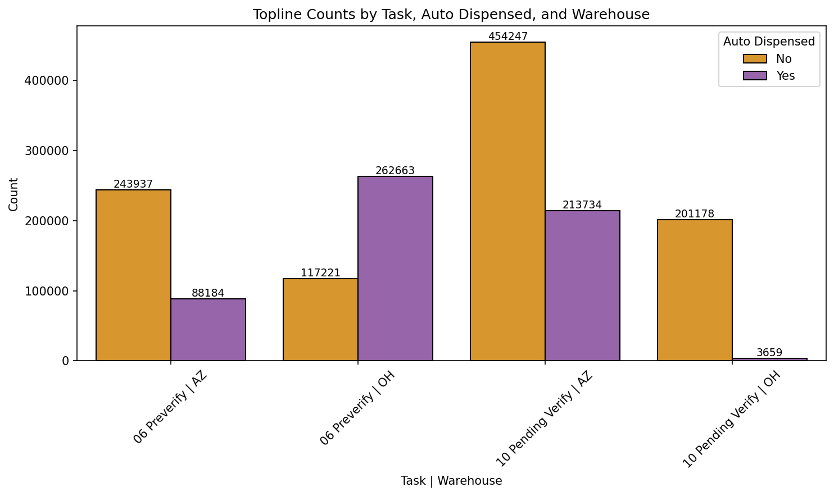

Ad Verify Topline Counts By Task Method Warehouse
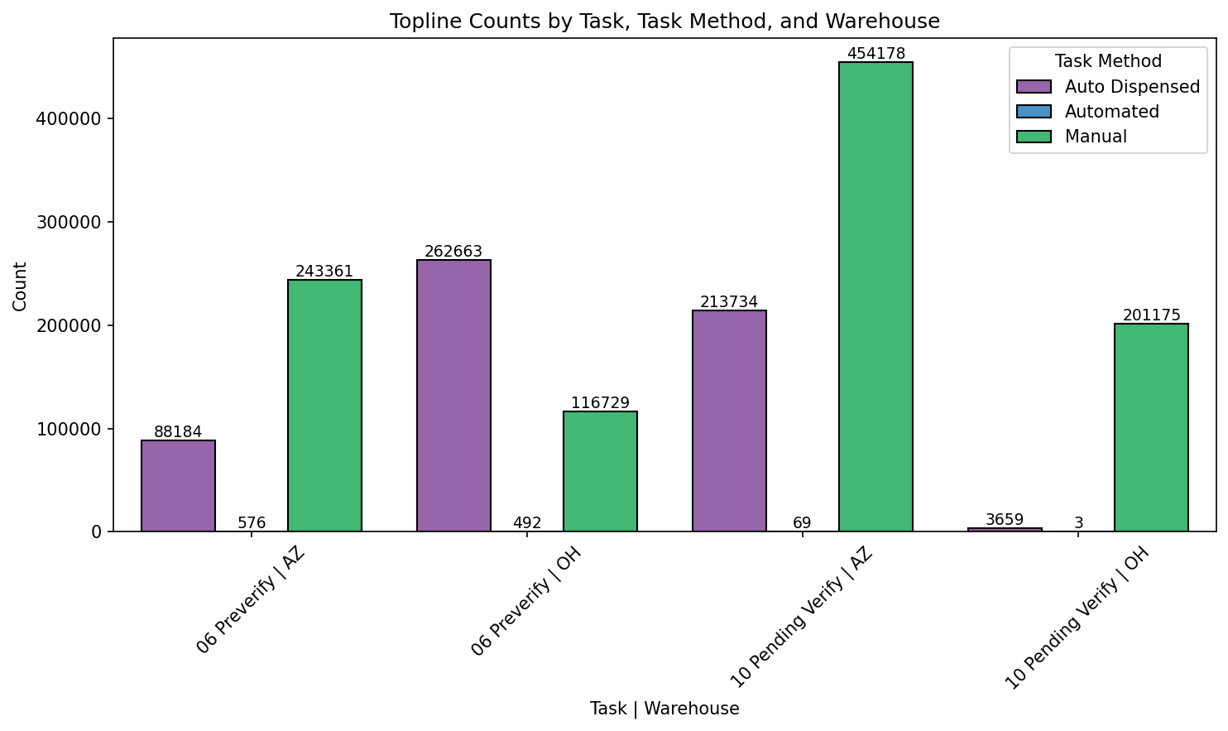

Ad Verify Histogram Overall
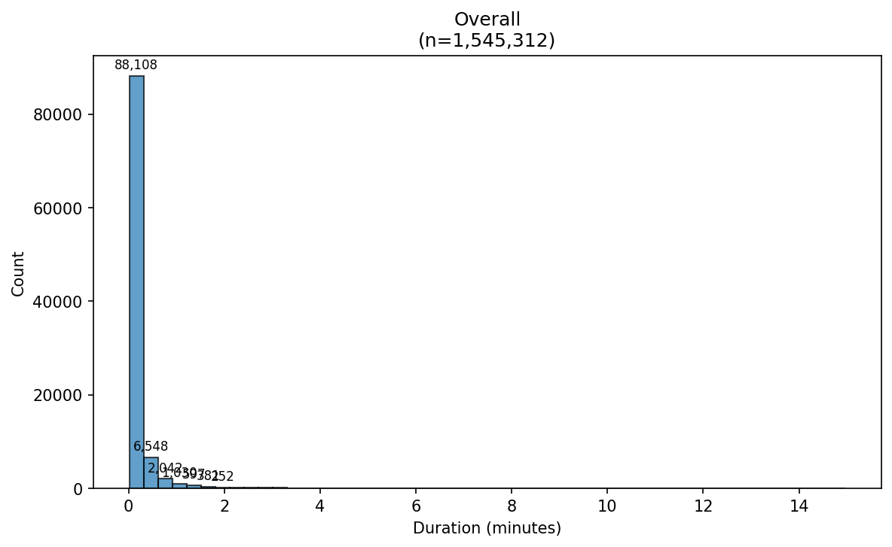

Ad Verify Histogram Auto Dispensed No
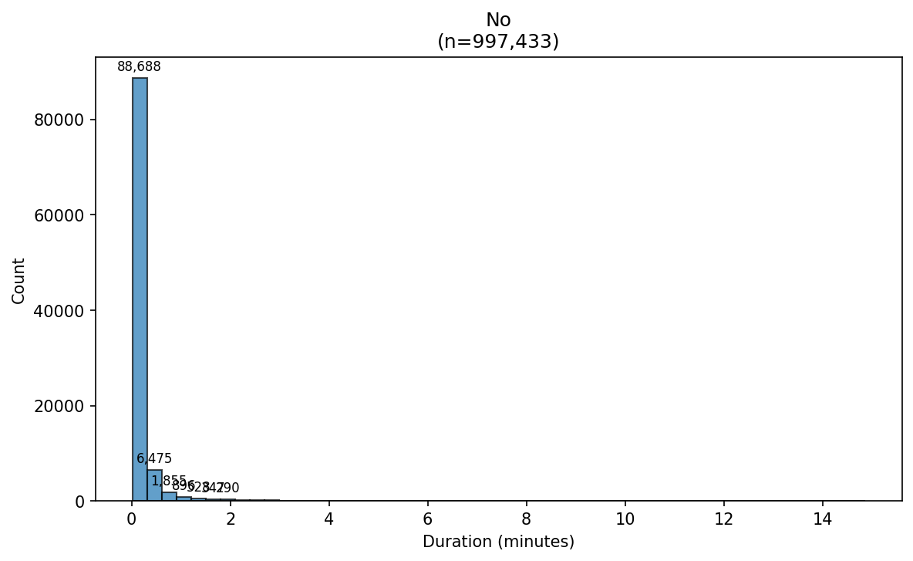

Ad Verify Histogram Auto Dispensed Yes
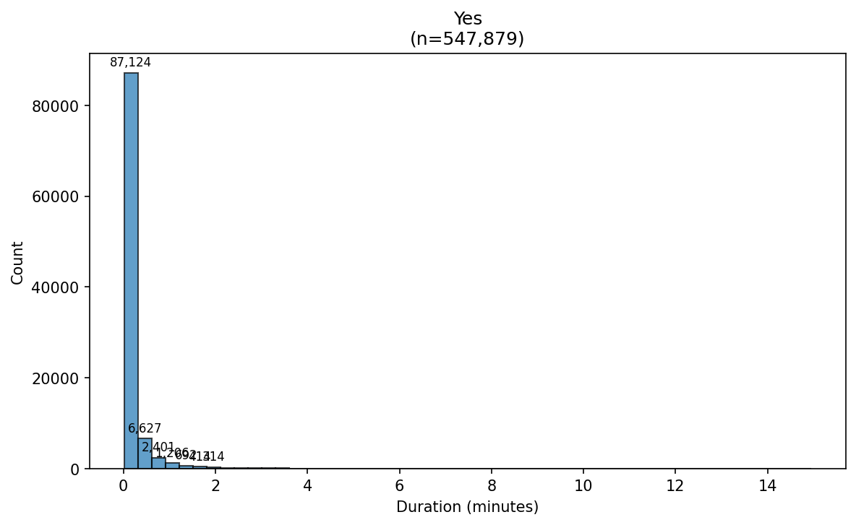

Ad Verify Histogram Auto Task Auto Disp No - 06 Preverify
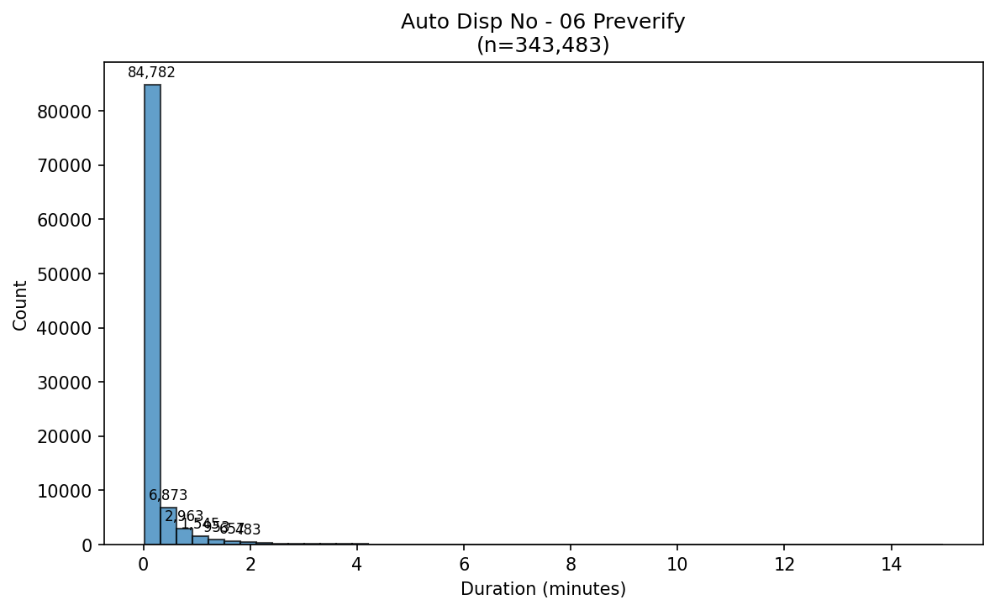

Ad Verify Histogram Auto Task Auto Disp No - 10 Pending Verify
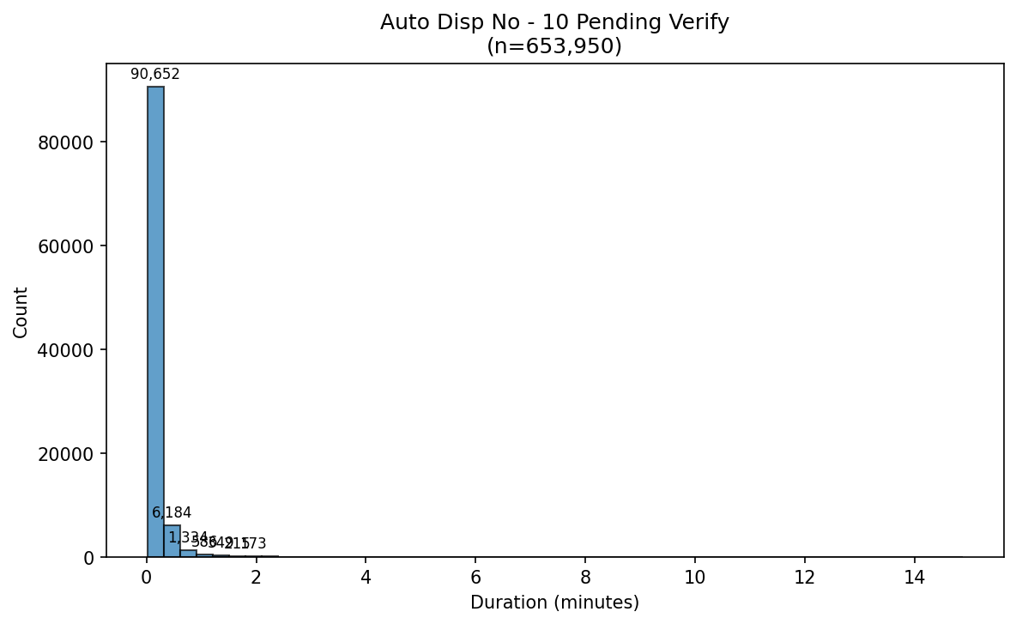

Ad Verify Histogram Auto Task Auto Disp Yes - 06 Preverify
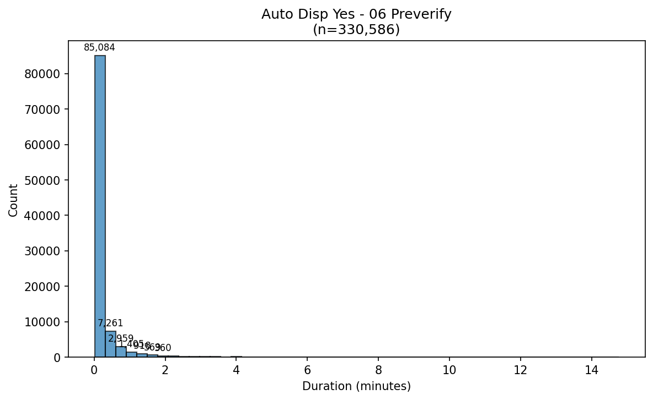

Ad Verify Histogram Auto Task Auto Disp Yes - 10 Pending Verify
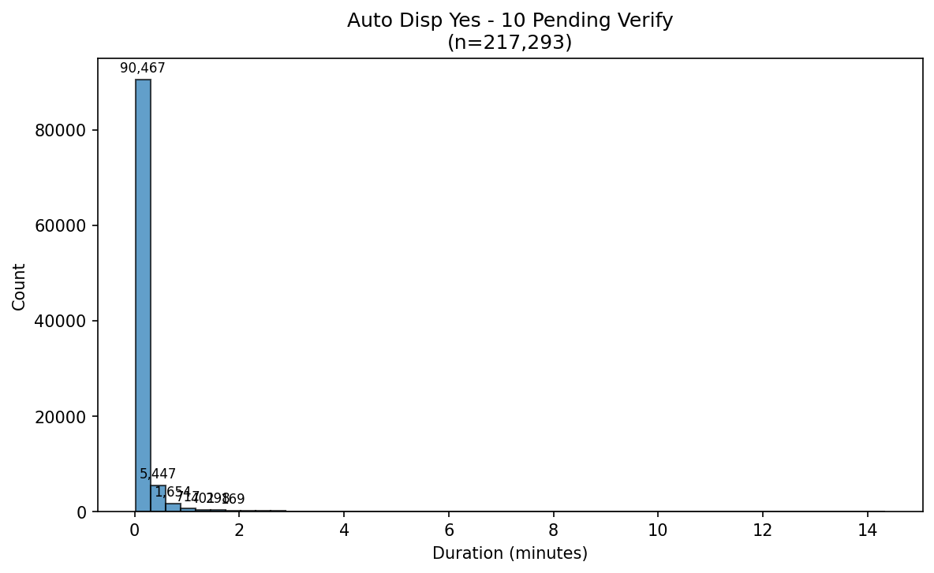

Ad Verify Histogram Mode Task Auto Dispensed - 06 Preverify
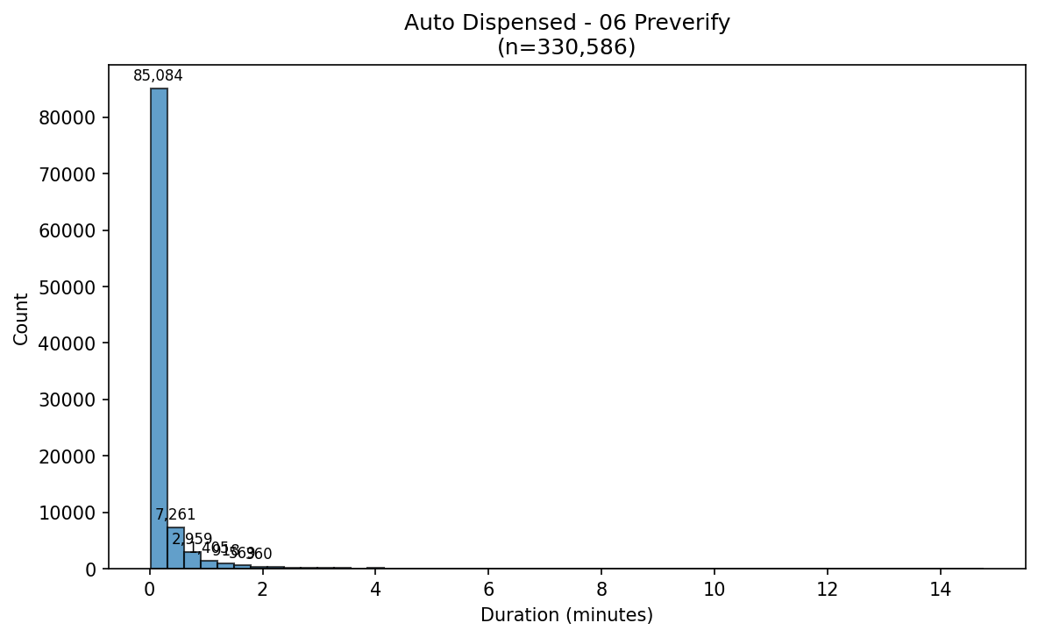

Ad Verify Histogram Mode Task Auto Dispensed - 10 Pending Verify
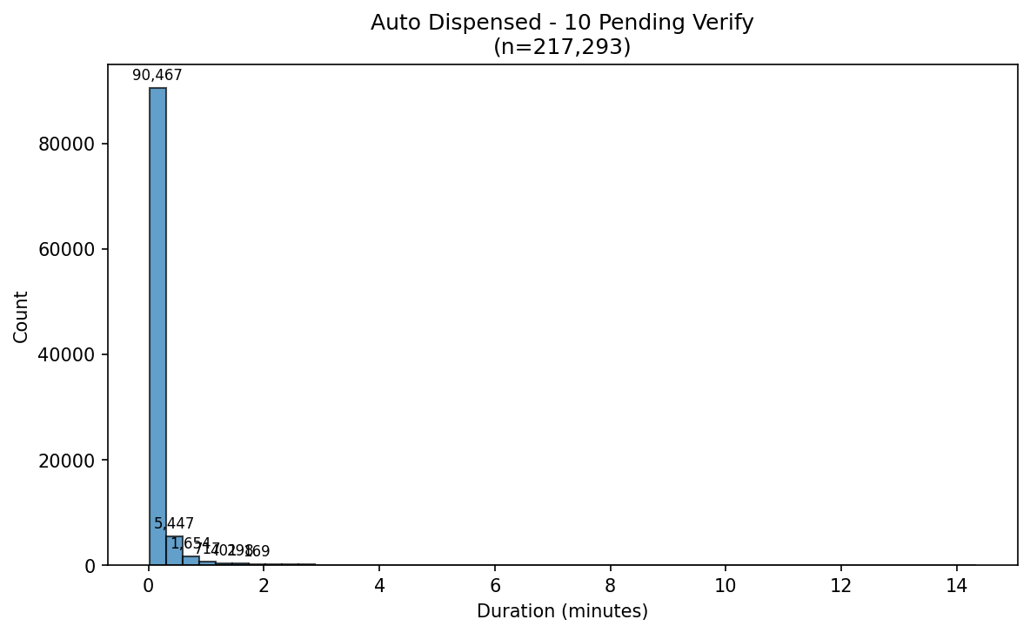

Ad Verify Histogram Mode Task Automated - 06 Preverify
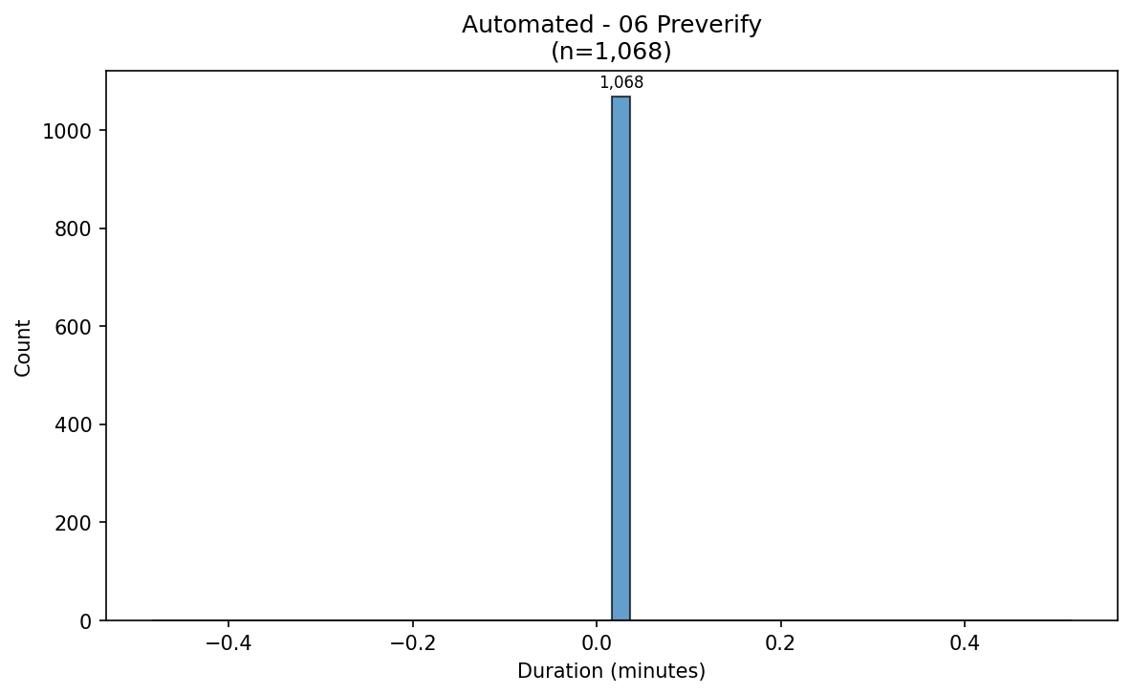

Ad Verify Histogram Mode Task Automated - 10 Pending Verify
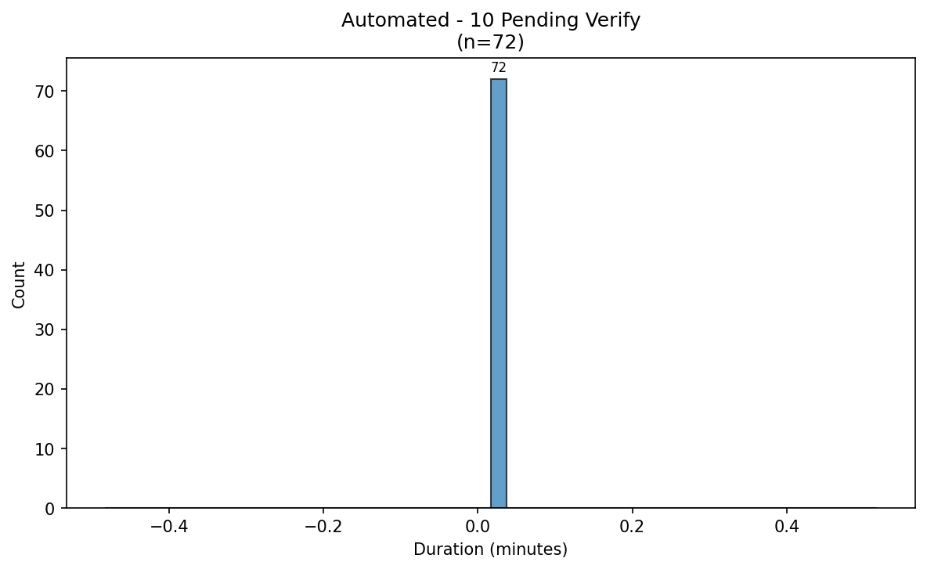

Ad Verify Histogram Mode Task Manual - 06 Preverify
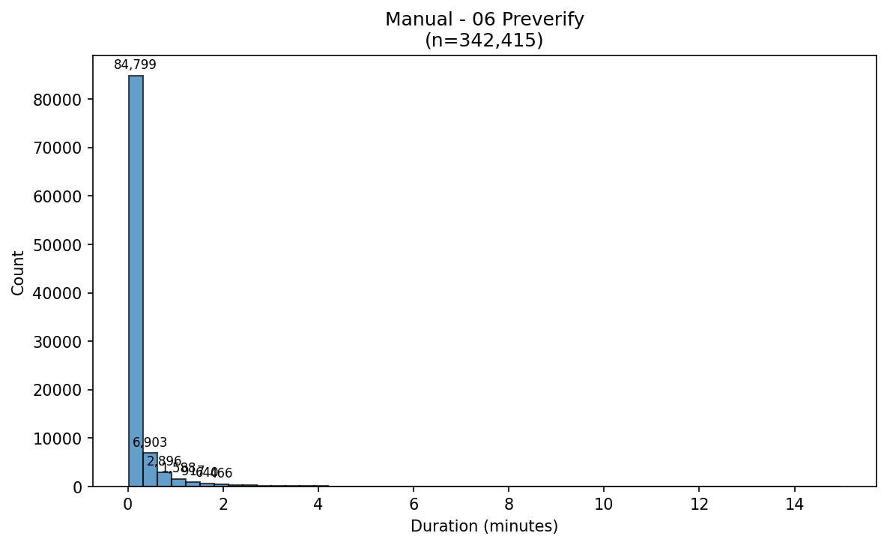

Ad Verify Histogram Mode Task Manual - 10 Pending Verify
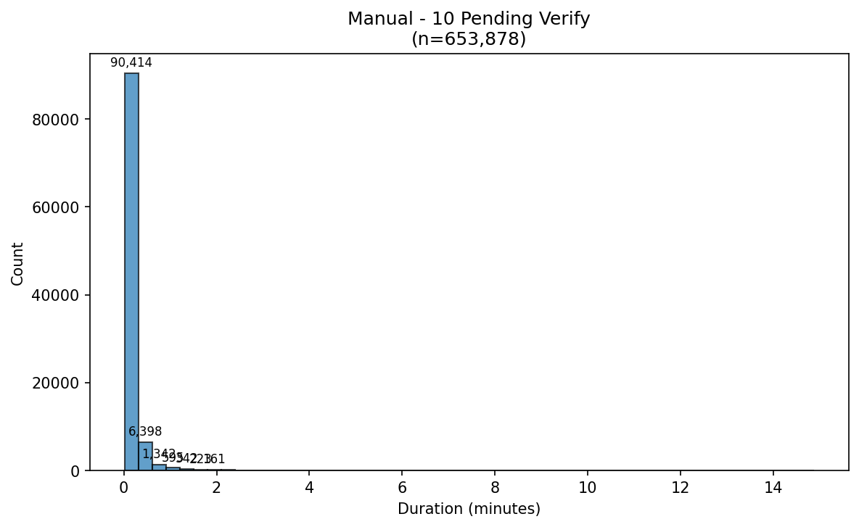

Ad Verify Histogram Task 06 Preverify
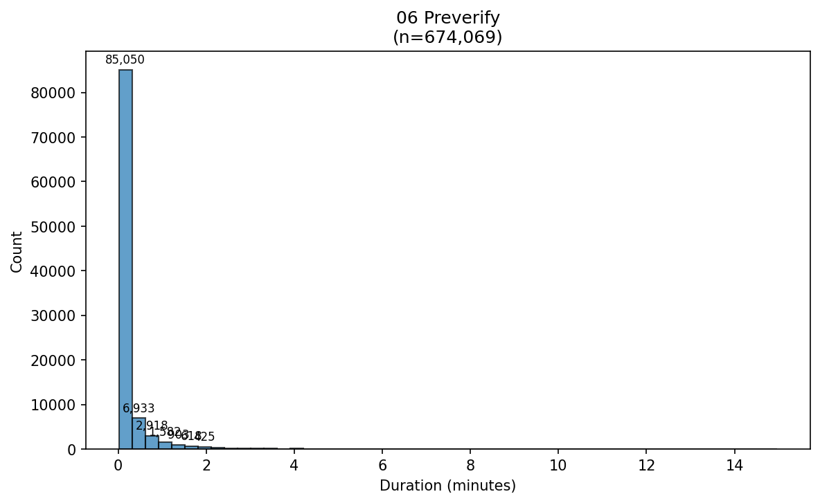

Ad Verify Histogram Task 10 Pending Verify
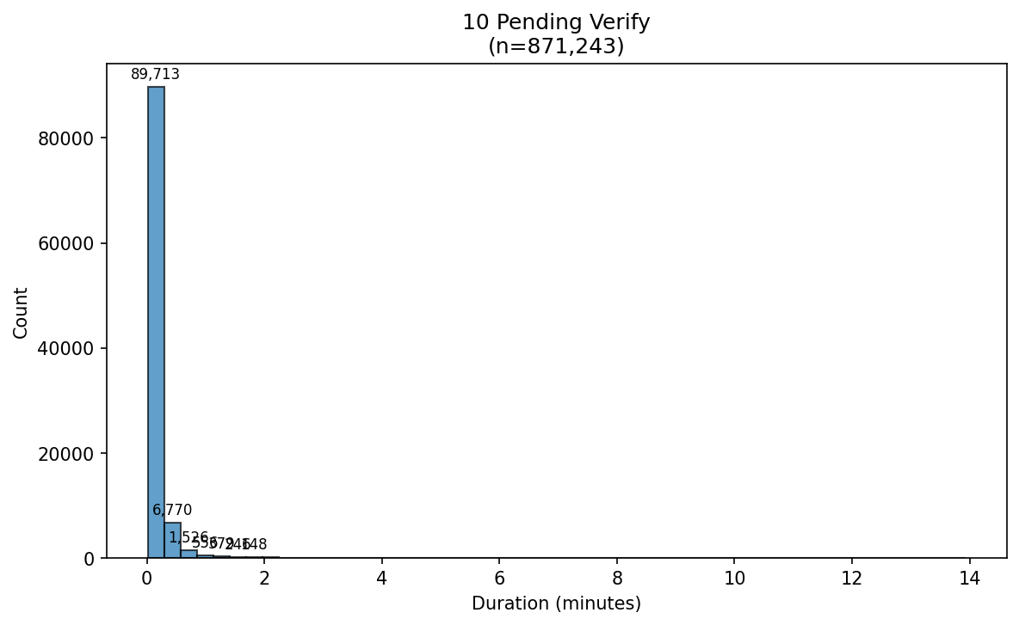

Ad Verify Histogram Task Mode Auto Dispensed
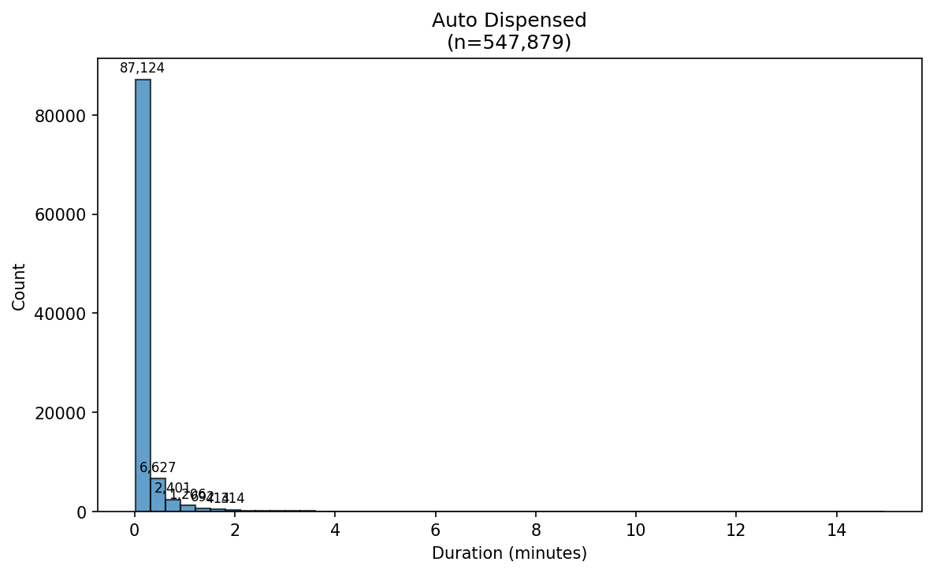

Ad Verify Histogram Task Mode Automated
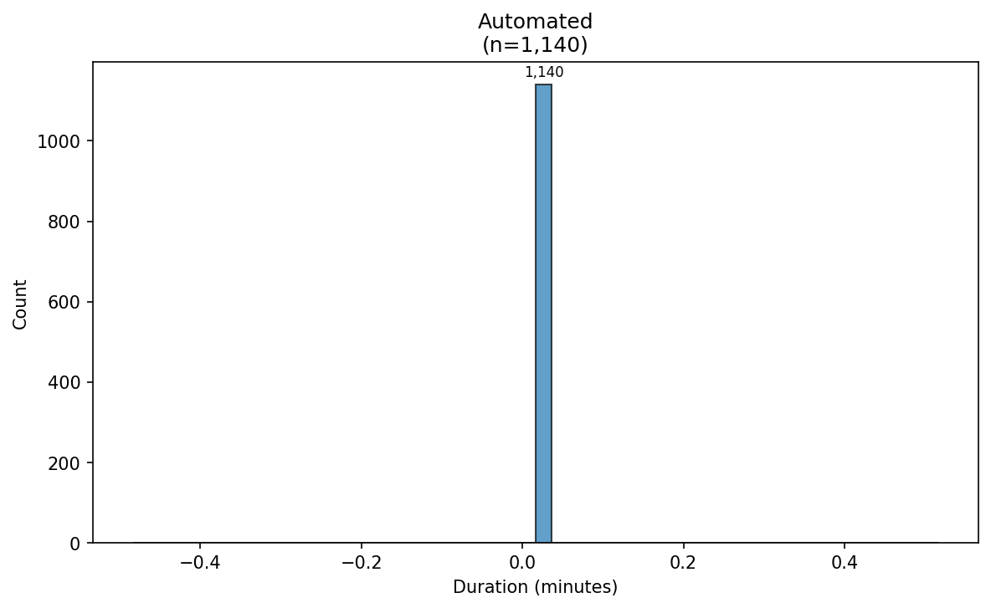

Ad Verify Histogram Task Mode Manual
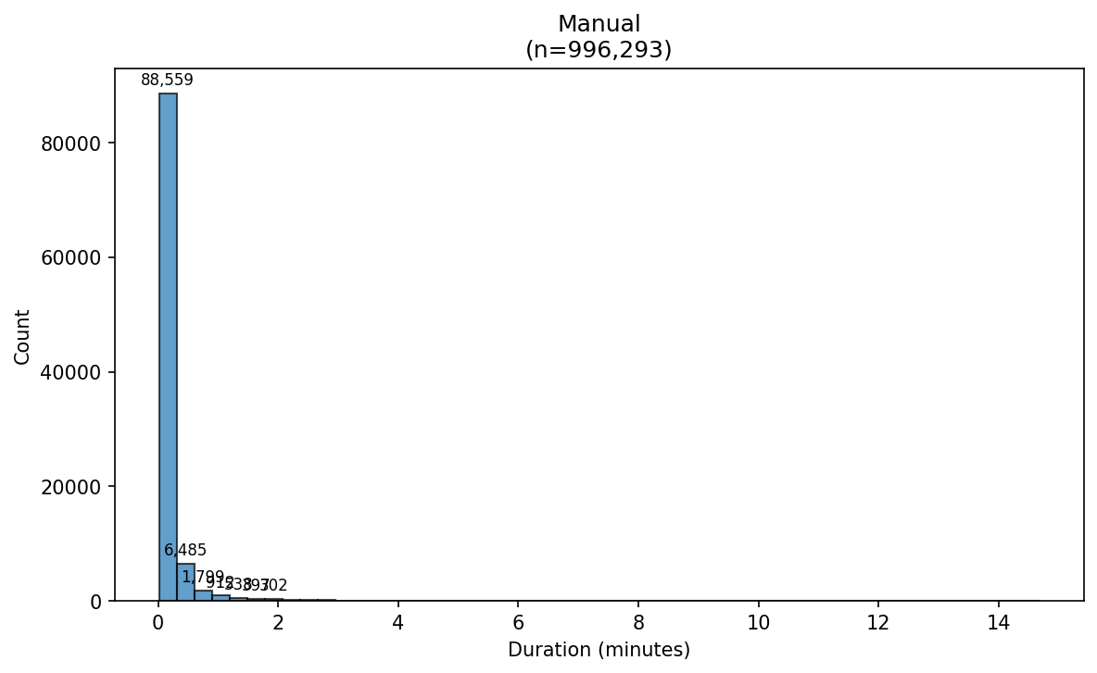

Ad Verify Histogram Task Wh 06 Preverify Az
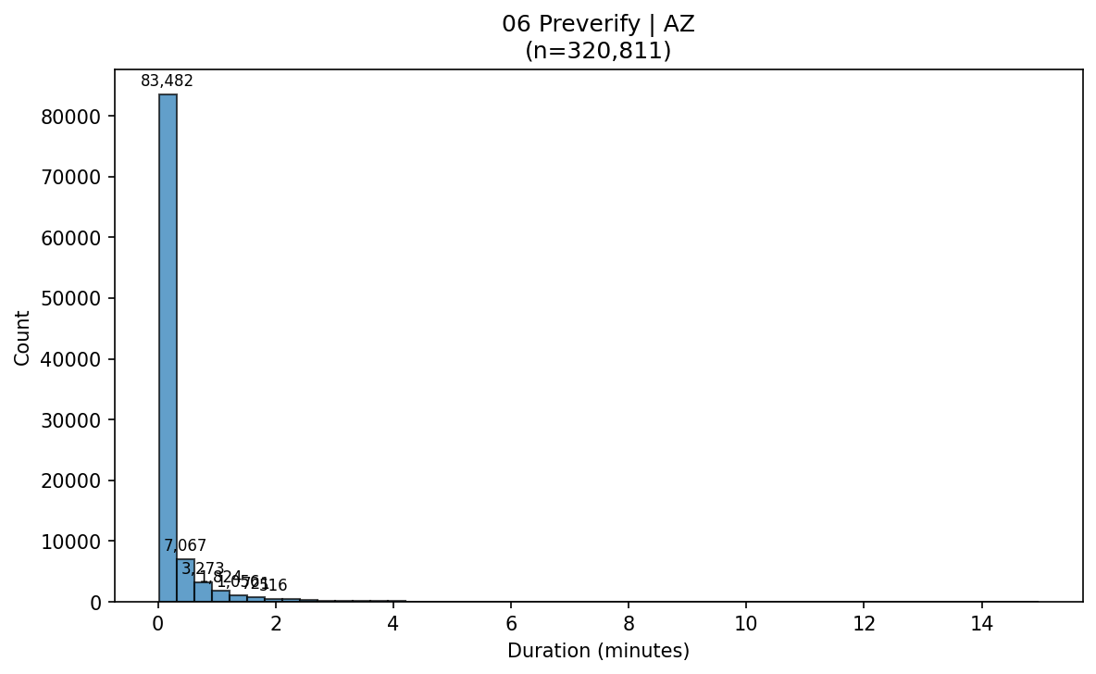

Ad Verify Histogram Task Wh 06 Preverify Oh
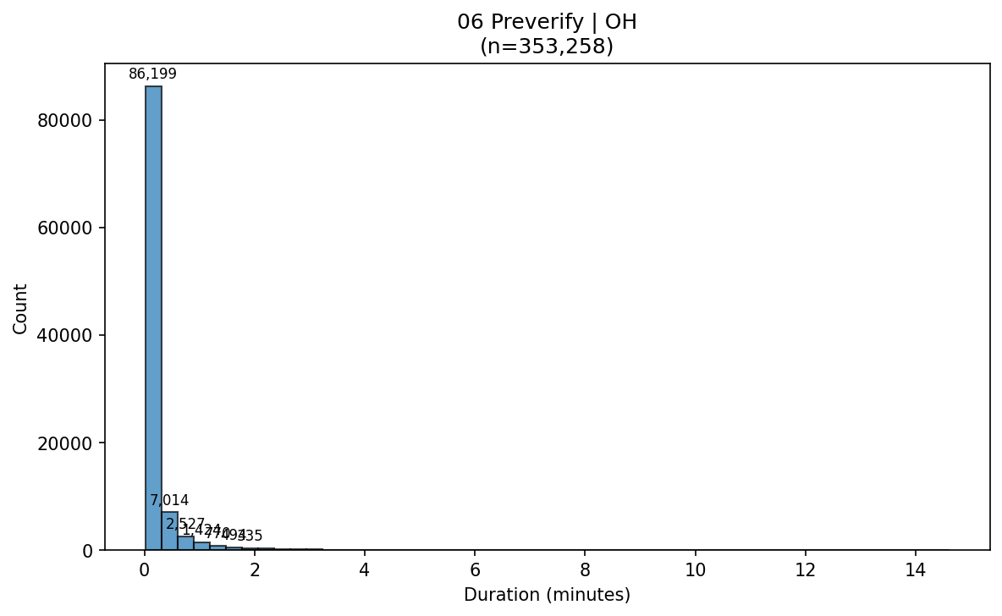

Ad Verify Histogram Task Wh 10 Pending Verify Az
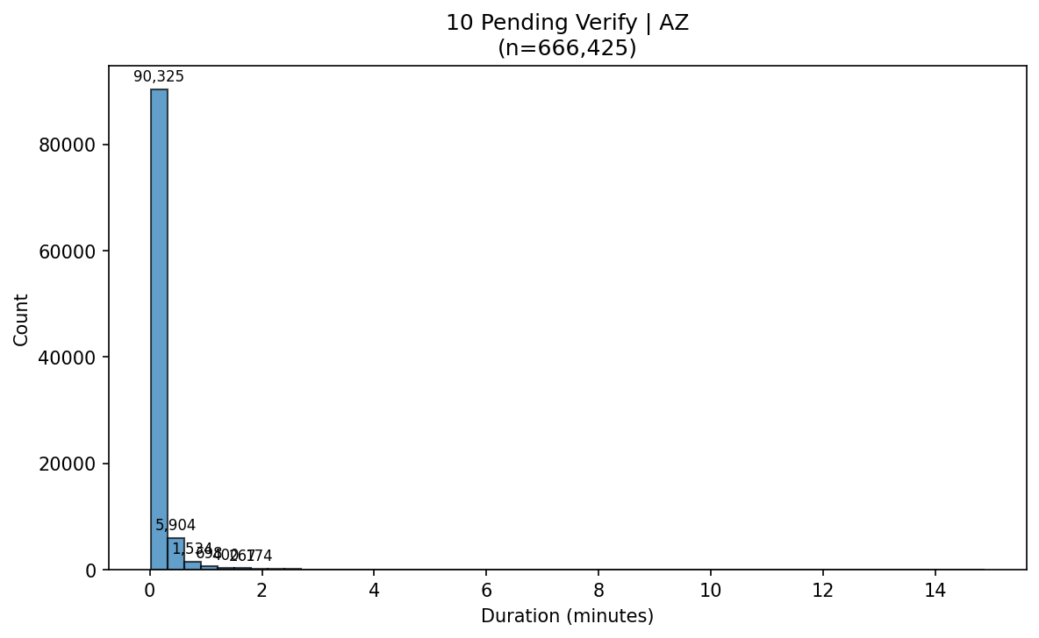

Ad Verify Histogram Task Wh 10 Pending Verify Oh
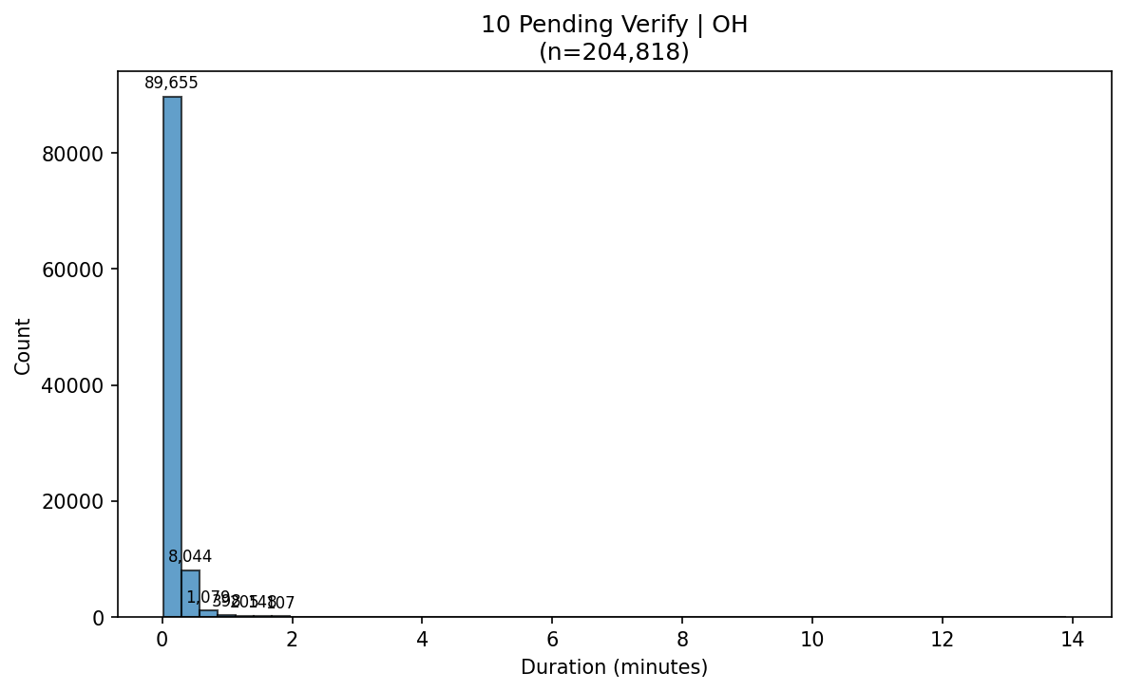

Ad Verify Histogram Wh Az
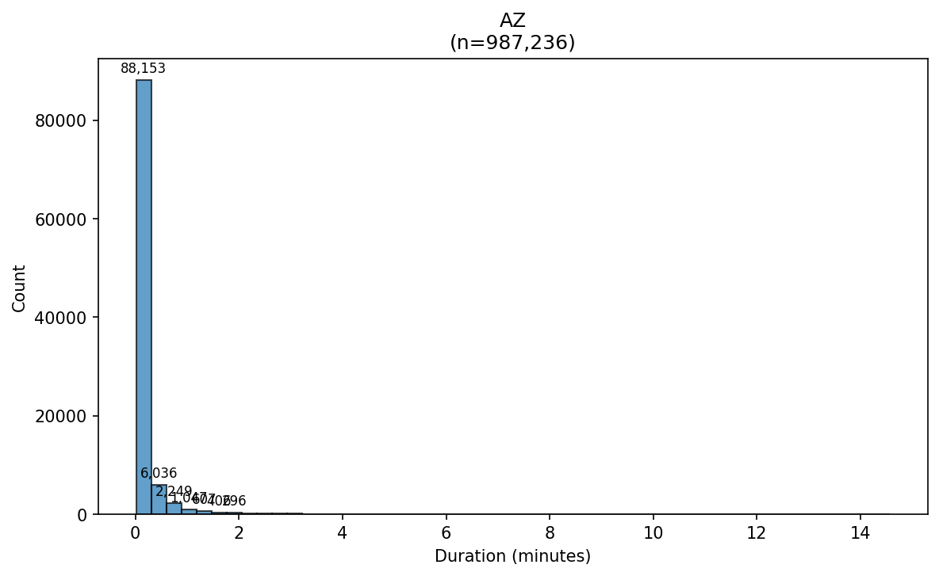

Ad Verify Histogram Wh Oh
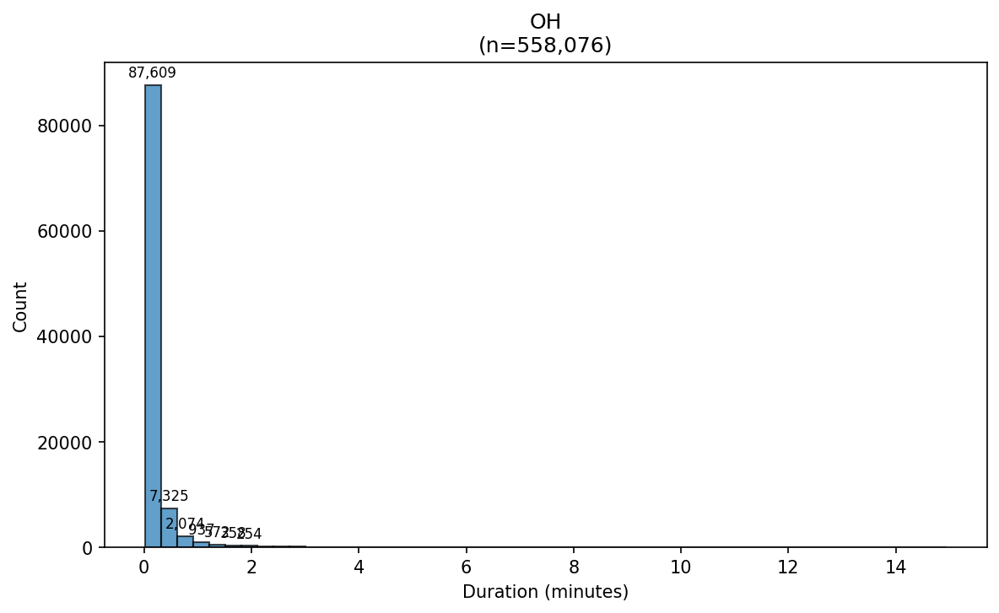

Ad Verify Kde Overall
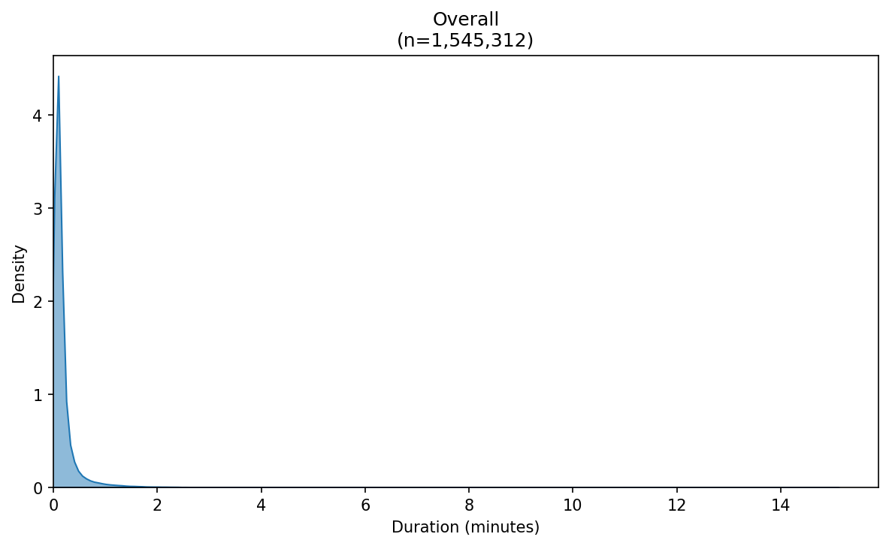

Ad Verify Kde Auto Dispensed No
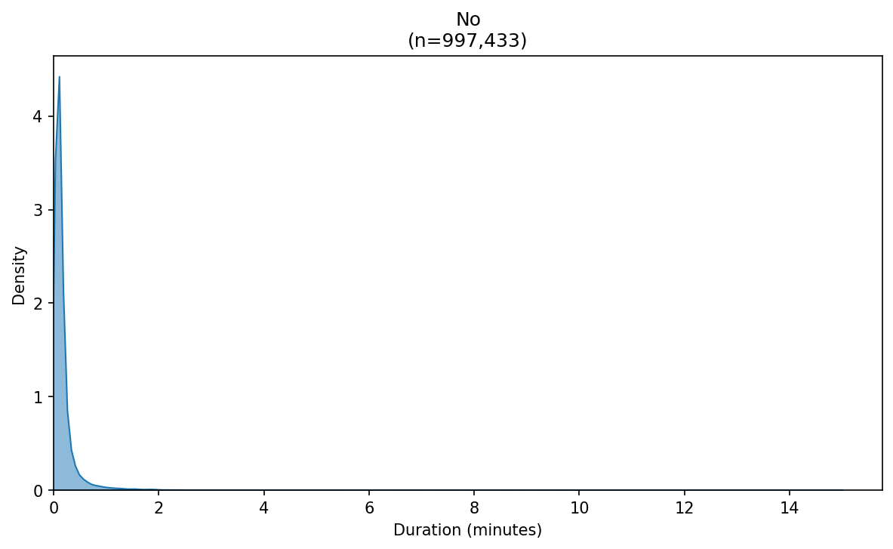

Ad Verify Kde Auto Dispensed Yes
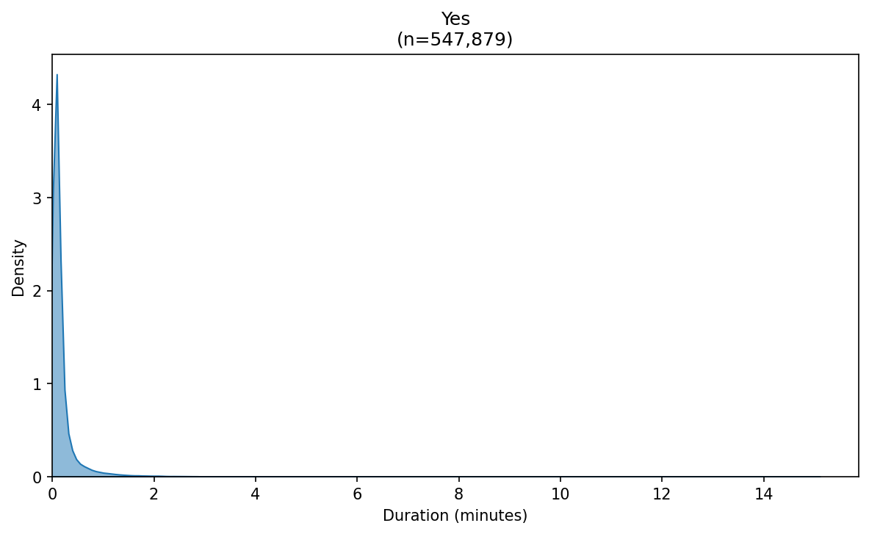

Ad Verify Kde Auto Task Auto Disp No - 06 Preverify
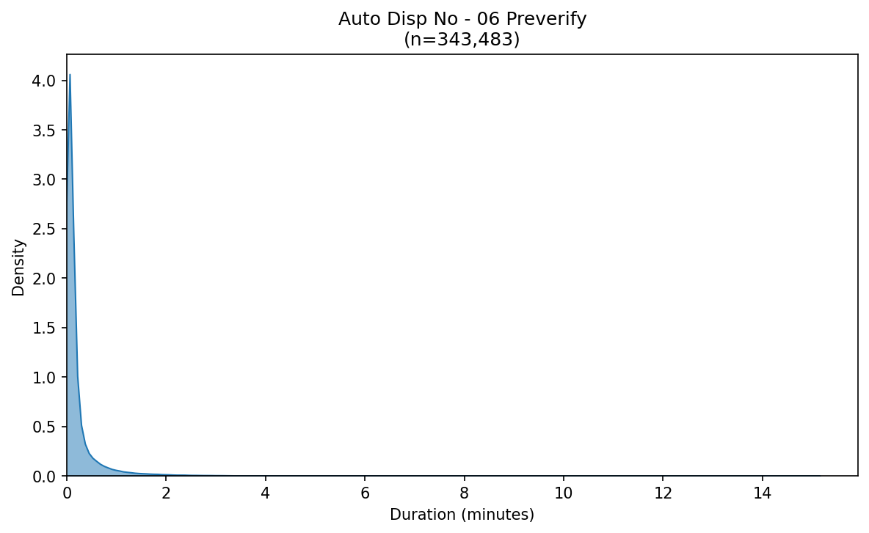

Ad Verify Kde Auto Task Auto Disp No - 10 Pending Verify
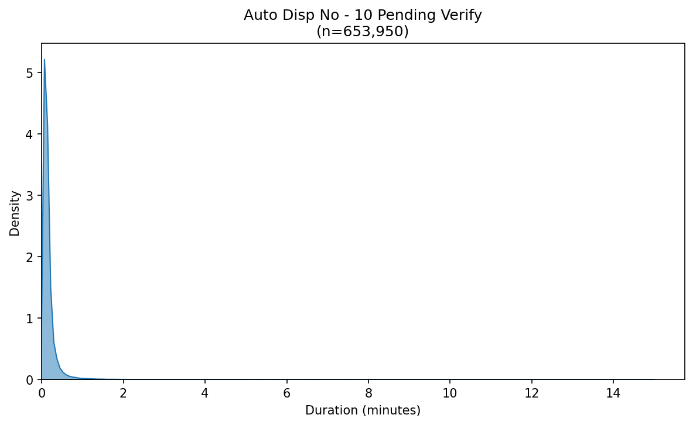

Ad Verify Kde Auto Task Auto Disp Yes - 06 Preverify
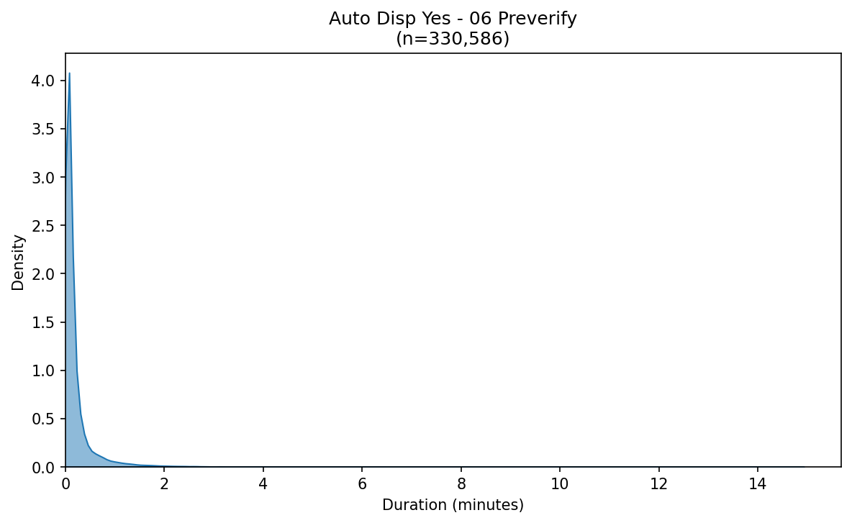

Ad Verify Kde Auto Task Auto Disp Yes - 10 Pending Verify
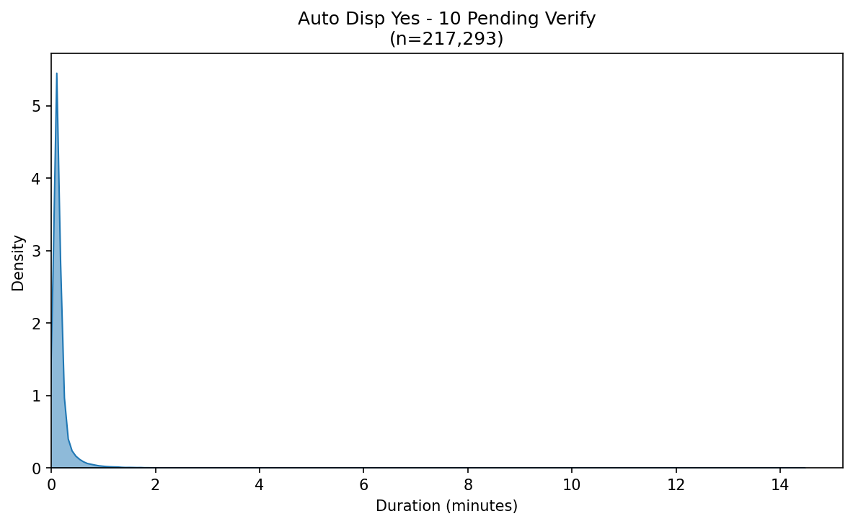

Ad Verify Kde Mode Task Auto Dispensed - 06 Preverify
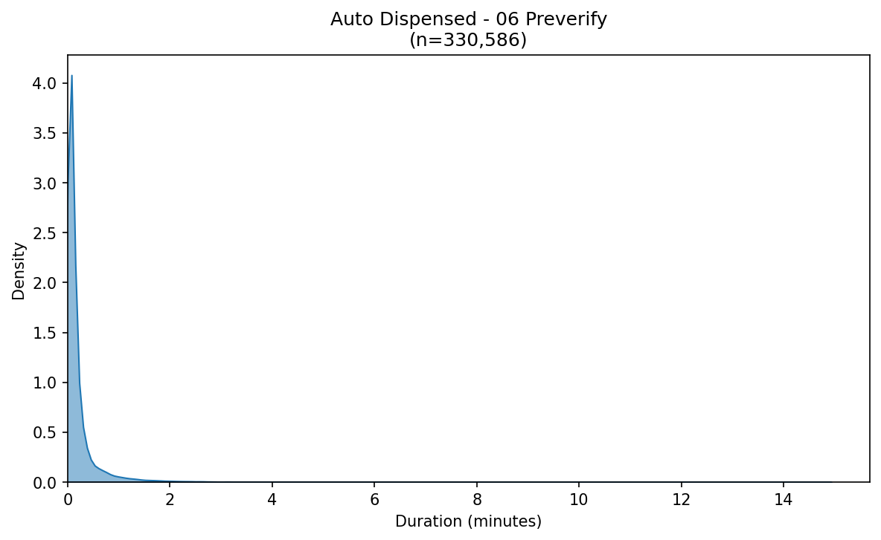

Ad Verify Kde Mode Task Auto Dispensed - 10 Pending Verify
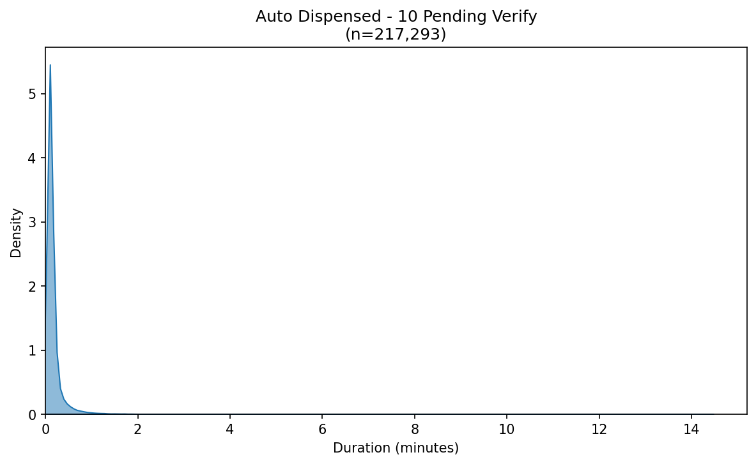

Ad Verify Kde Mode Task Automated - 06 Preverify
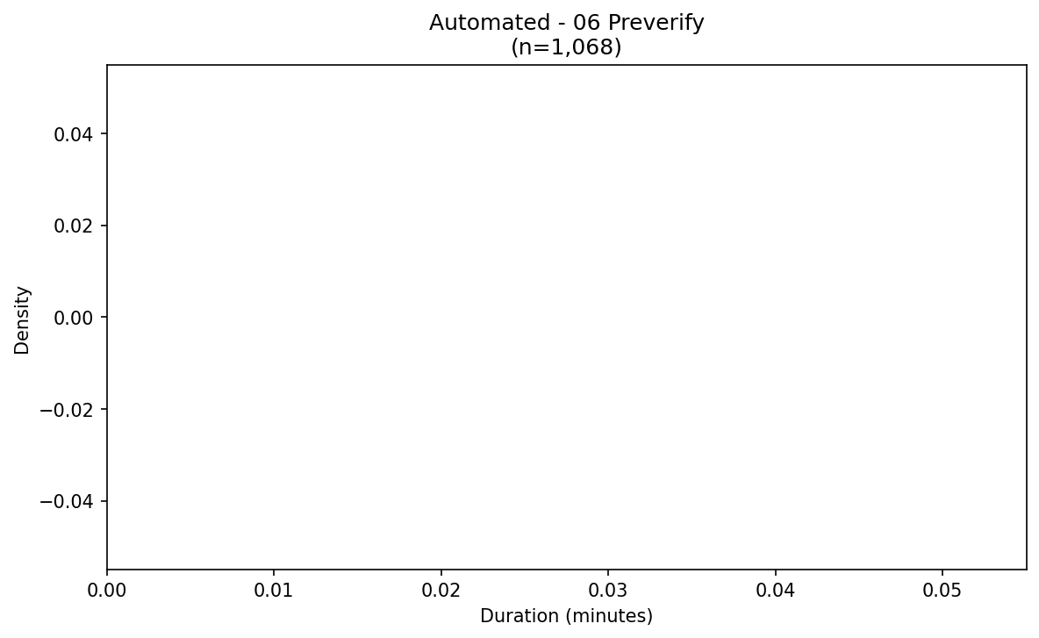

Ad Verify Kde Mode Task Automated - 10 Pending Verify
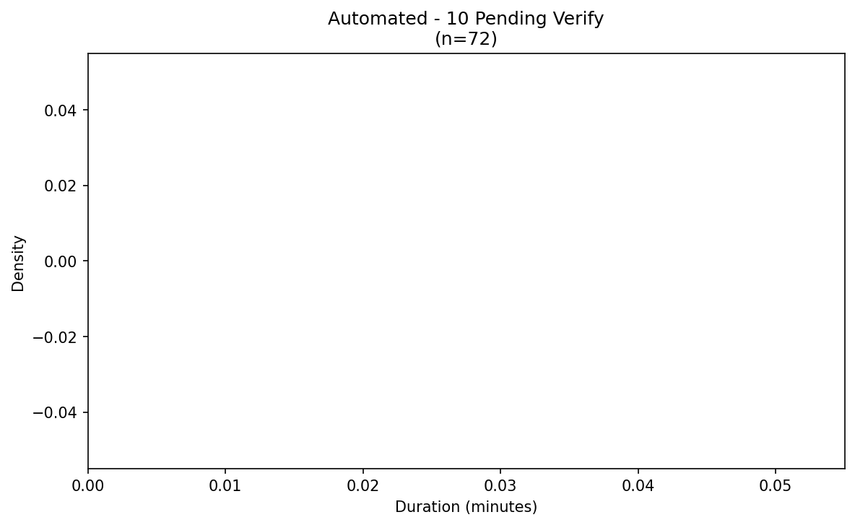

Ad Verify Kde Mode Task Manual - 06 Preverify
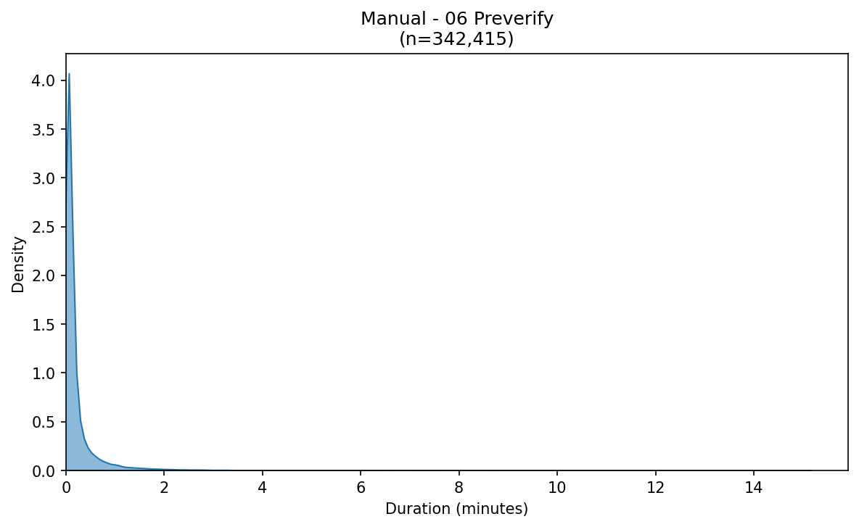

Ad Verify Kde Mode Task Manual - 10 Pending Verify
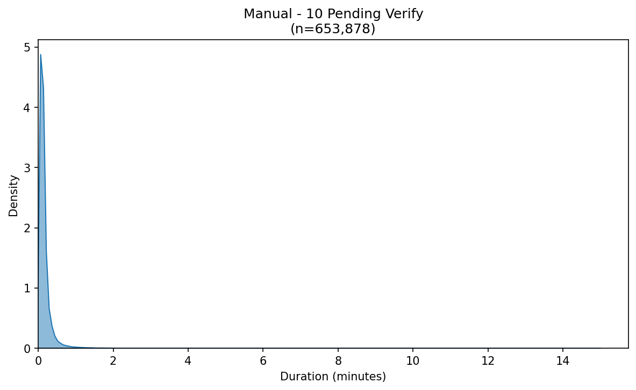

Ad Verify Kde Task 06 Preverify
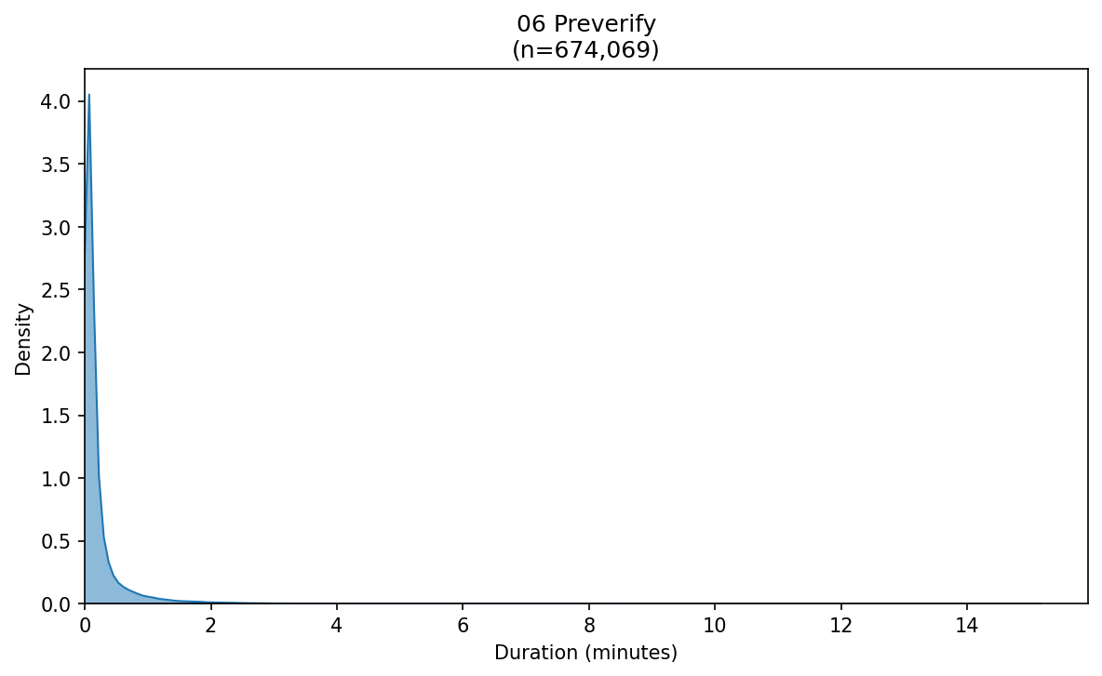

Ad Verify Kde Task 10 Pending Verify
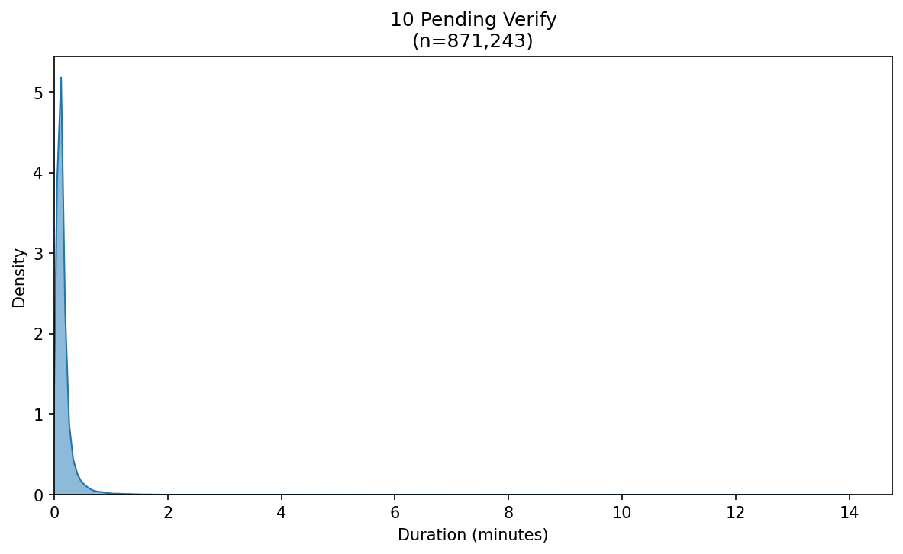

Ad Verify Kde Task Mode Auto Dispensed
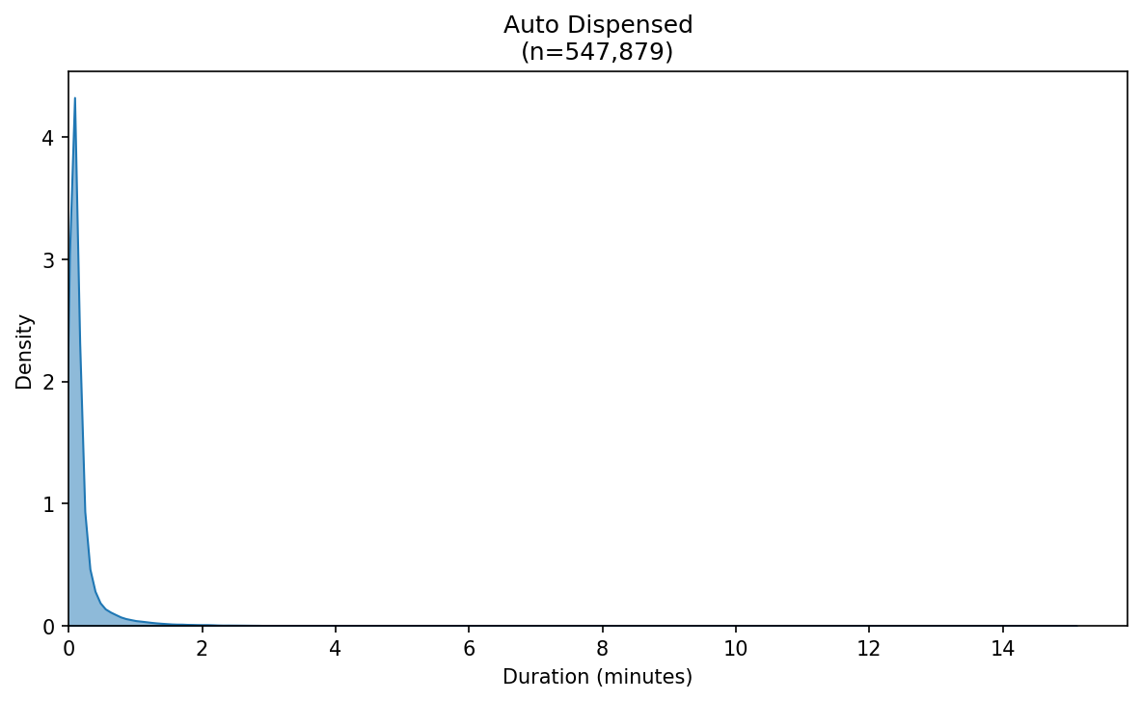

Ad Verify Kde Task Mode Automated
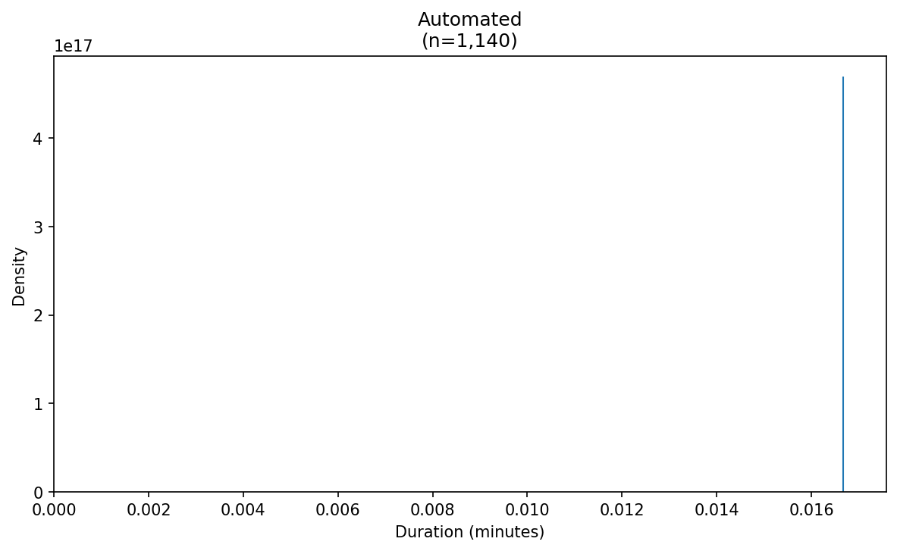

Ad Verify Kde Task Mode Manual
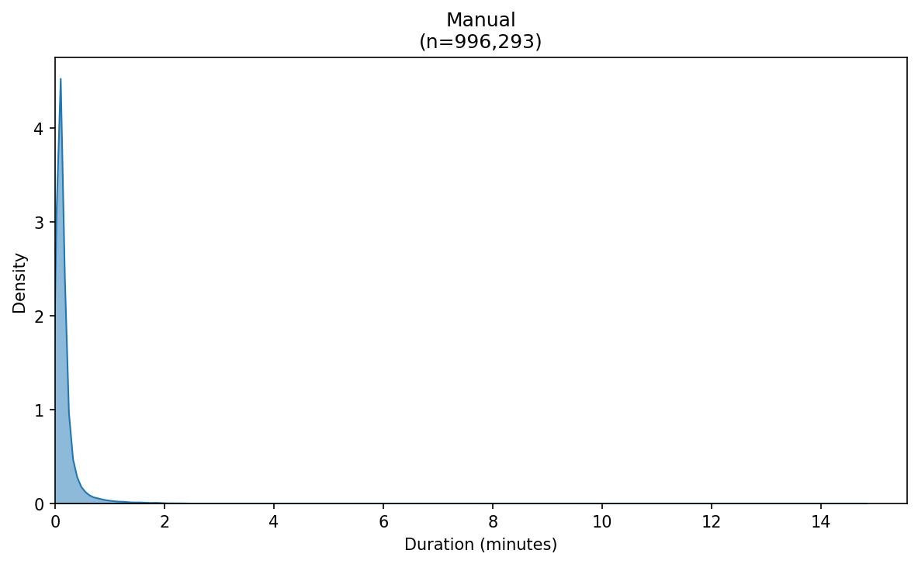

Ad Verify Kde Task Wh 06 Preverify Az
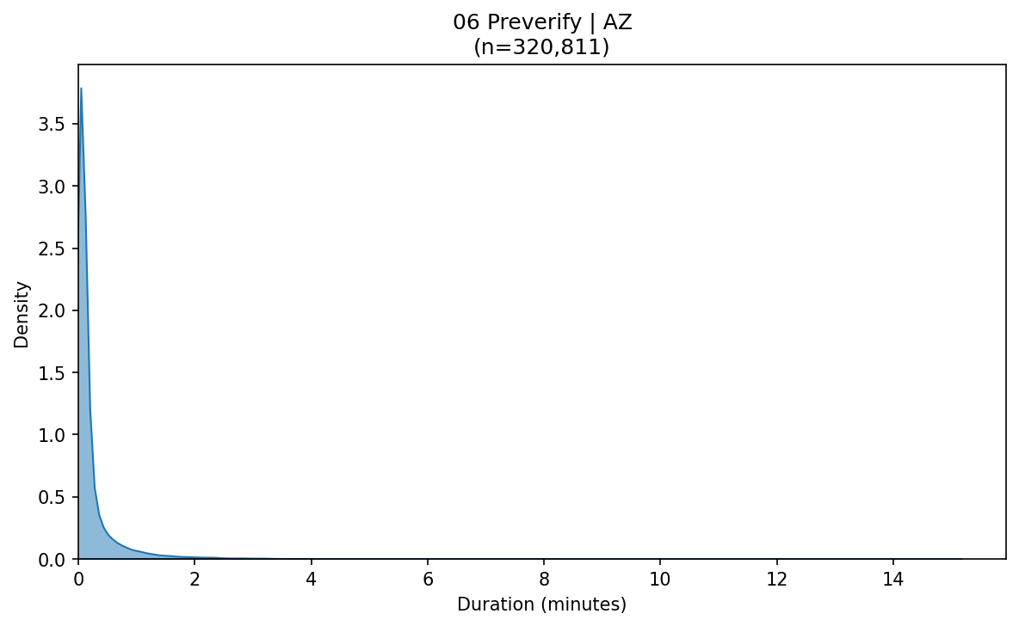

Ad Verify Kde Task Wh 06 Preverify Oh
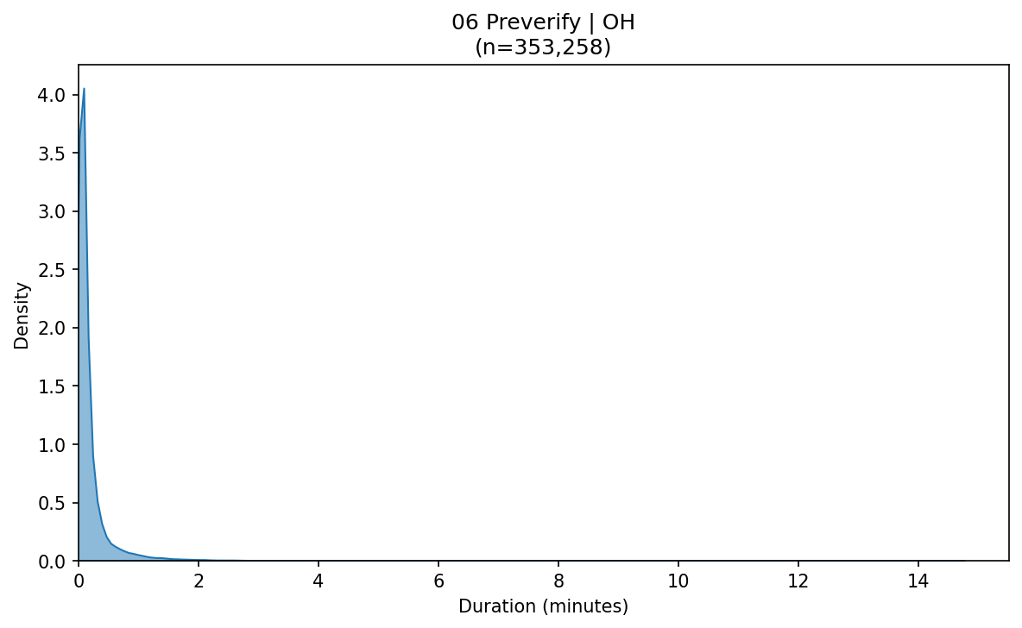

Ad Verify Kde Task Wh 10 Pending Verify Az
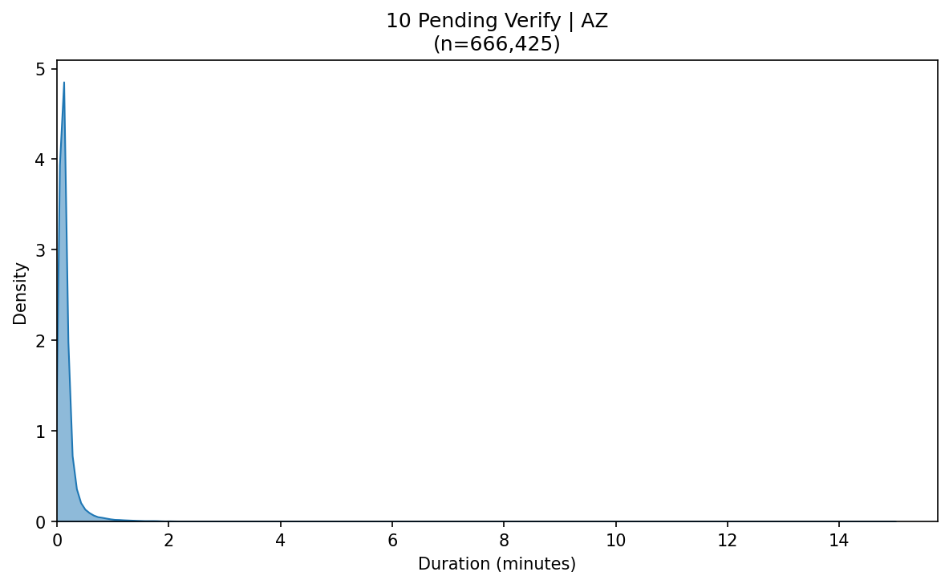

Ad Verify Kde Task Wh 10 Pending Verify Oh
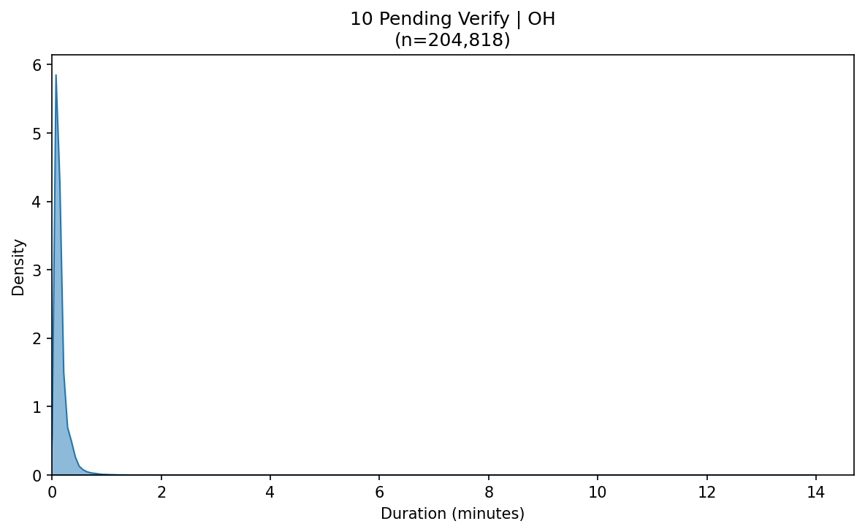

Ad Verify Kde Wh Az
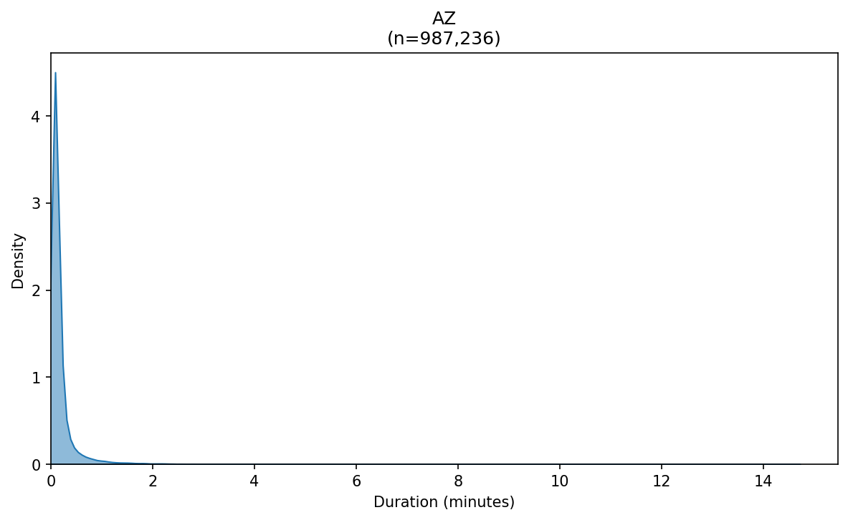

Ad Verify Kde Wh Oh
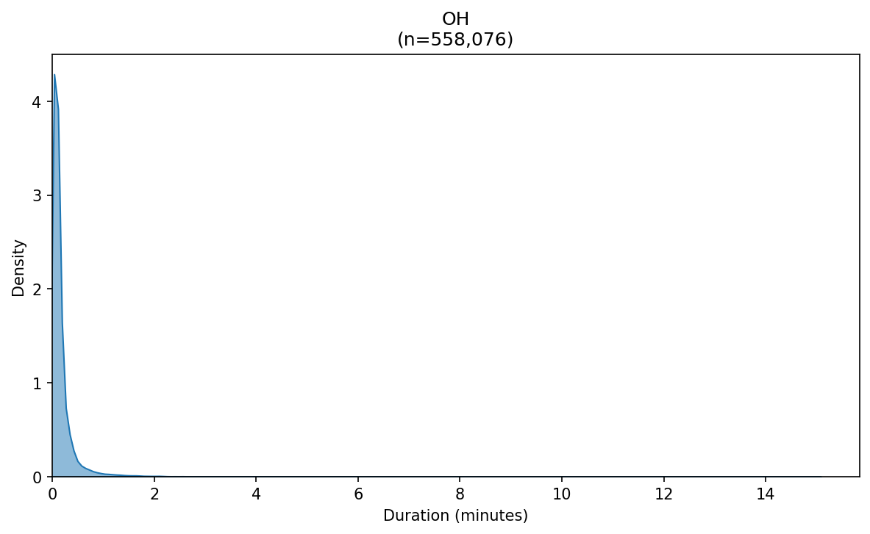

Ad Verify Manual First Minute Breakdown
